Section 1: Case Summary

Scenario Title: | Gun Shot Wound to Lower Back
Keywords: | Penetrating Trauma, Team Management
Brief Description of Case: | A 20-year-old male is dropped off at a community ED after a gunshot wound to the lower back. He will quickly be placed in a resuscitation bed and placed on monitors. His initial vitals will include tachycardia but no hypotension. The team will proceed through their primary survey and identify only one gunshot wound. If they do not recognize possible free fluid and the need for blood, the patient will become increasingly hypotensive. They will be required to intubate the patient while waiting for the staff surgeon to arrive in order for the patient to go to the OR.

Goals and Objectives
Educational Goal: | To expose learners to the management of gunshot wounds and free fluid in the abdomen.
Objectives:  (Medical and CRM) | CRM:  - Effectively lead a clinical team in a non-trauma centre.  Medical:  - Perform safe and thorough primary survey.  - Recognize free fluid in the abdomen and appropriately resuscitate while arranging definitive management.  - Administer massive transfusion in appropriate blood product ratio using adjuncts to increase speed of delivery (e.g. pressure bag, level one).
EPAs Assessed: | F1: Initiating and Assisting In Resuscitation of Critically Ill Patients  C2: Resuscitating & Coordinating Care For a Critically Injured Patient (Trauma)

Learners, Setting and Personnel
Target Learners: | ☒ Junior Learners |  | ☐ Senior Learners |  |  | ☐ Staff
 | ☒ Physicians | ☐ Nurses |  | ☐ RTs | ☐ Inter-professional
 | ☐ Other Learners:
Location: | ☒ Sim Lab |  | ☐ In Situ |  |  | ☐ Other:
Recommended Number of Facilitators: | Instructors: 1
 | Sim Actors: 1 (Bedside nurse)
 | Sim Techs: 1

Scenario Development
Date of Development: | 17/04/2015
Scenario Developer(s): | Dr Kyla Caners
Affiliations/Institutions(s): | McMaster University
Contact E-mail:
Last Revision Date: | April 2021
Revised By: | Drs Chris Heyd and Chad Singh
Version Number: | 2.0

Section 2A: Initial Patient Information

- Patient Chart
Patient Name: Unknown Male |  |  |  | Age: 20’s | Gender: M | Weight: 70kg
Presenting complaint: GSW to the lower back
Temp: 36.2ºC | HR: 130/min | BP: 105/65 |  | RR: 28/min | O₂Sat: 99% RA | FiO₂: Nil
Cap glucose: 6.4 mmol/L |  |  |  | GCS: 13 (E4 V4 M5)
Triage note:
20-something year old unknown male brought in a wheelchair by friends. They were at a party and a fight broke out. It was loud and dark and then they saw the patient collapse. His low back is covered in blood. He is awake but moaning. Unknown identity/meds/allergies.
Allergies: Unknown
Past Medical History:  Unknown |  |  | Current Medications:  Unknown

Section 2B: Extra Patient Information

A. Further History
Include any relevant history not included in triage note above. What information will only be given to learners if they ask? Who will provide this information (mannequin’s voice, sim actors, SP, etc.)?

Friends left after dropping the patient off at triage. No further history is available.

B. Physical Exam
List any pertinent positive and negative findings
Cardio: No murmur. Clear HS. | Neuro: PERLA. No signs HI. Only yes or no to pain.
Resp: Tachypnea. Good A/E throughout. Shallow resps. | Head & Neck: No hemotympanum. No battle/raccoon. No signs HI.
Abdo: Distended. Firm. Tender. Normal rectal tone. | MSK/skin: Moving all limbs to pain. Small wound to left flank that is oozing blood. No other spinal tenderness. Pale skin.
GU: No blood at meatus.
Other: Nil

Section 3: Technical Requirements/Room Vision

A. Patient
☒ Mannequin – Adult
☐ Standardized Patient
☐ Task Trainer
☐ Hybrid
B. Special Equipment Required
Level 1 transfusion machine
Pressure bags
IO Kit
Standard resuscitation equipment

C. Required Medications
Standard resuscitation medications
TXA
Blood products

D. Moulage
1 cm round wound placed over left flank/low back at approximately L2. Patient should look or be described as very pale.

E. Monitors at Case Onset
☐ Patient on monitor with vitals displayed
☒ Patient not yet on monitor
F. Patient Reactions and Exam
Include any relevant physical exam findings that require mannequin programming or cues from patient
(e.g. – abnormal breath sounds, moaning when RUQ palpated, etc.) May be helpful to frame in ABCDE format.

Patient to moan with palpation of abdomen or near GSW.
Drowsy but will answer “yes-no” questions.

Section 4: Sim Actor and Standardized Patients

Sim Actor and Standardized Patient Roles and Scripts
Role | Description of role, expected behavior, and key moments to intervene/prompt learners. Include any script required (including conveying patient information if patient is unable)
Bedside Nurse | Assist at bedside. Cue team to patient’s status PRN

Section 5: Scenario Progression

Scenario States, Modifiers and Triggers
Patient State/Vitals | Patient Status | Learner Actions, Modifiers & Triggers to Move to Next State |  | Facilitator Notes
1. Baseline State  Rhythm: sinus tach  HR: 120/min  BP: 105/65  RR: 22/min  O₂SAT: 96%  T: 36.2ºC  GCS: 13 | Moaning and complaining of pain. Pale. | Expected Learner Actions  IV access, monitors  Send trauma labs  Primary survey  Complete exposure & DRE  Give tranexamic acid 1g IV  Analgesia (Fentanyl)  Call for blood  FAST, CXR & AXR  Call for OR/surgeon | Modifiers  - Turn without analgesia -> HR 130  - Calls for OR “surgeon is on her way”  - 2 units available quickly -> “the rest coming from blood bank”  Triggers  - No blood or call for OR by 5 minutes -> 3. Hypotension  - Intubate -> 2. Intubation | Abx and Td should be delayed until patient is more stable.
2. Intubation  HR 115  BP 110/60 | Unchanged. | Expected Learner Actions  Pre-oxygenate  Ensure adequate access  Administer RSI | Modifiers  - Propofol given -> BP 60/35  - Pre-oxygenate -> O2: 99%  Triggers  - Intubate before blood products started -> 3. Hypotension  - Successful intubation -> 4. Resolution | Learners may use other induction agents, BP will still transiently drop.
3. Hypotension  HR 135  BP 75/40  RR 24 (if intubated, 12)  O2 94% | Either intubated or unchanged for start. | Expected Learner Actions  Call for and give blood  Initiate massive transfusion  FAST (if not yet done)  Call for OR/surgeon | Modifiers  - Gives 2 unit pRBC -> BP 85/50  Triggers  - Initiate massive transfusion –> 4. Resolution  - 10 minutes -> 4. Resolution | Blood bank to call leader to say, “We don’t have a protocol, what blood products do you want?”
4. Resolution  HR 110  BP 100/60  RR 24 (if intubated, 12)  O2 94% (if intubated, 100%) |  | Expected Learner Actions  Initiate massive transfusion  FAST (if not yet done)  Call for OR/surgeon  Give Td 0.5ml IM  Give Abx (CTX/flagyl) | Triggers  - 4 units pRBC given, OR called for, patient intubated -> “OR is ready” [END CASE]  - 15 minutes -> “OR is ready” [END CASE]

Appendix A: Laboratory Results

None given in case

Appendix B: ECGs, X-rays, Ultrasounds and Pictures

Paste in any auxiliary files required for running the session. Don’t forget to include their source so you can find them later!

CXR – Report Normal

Pelvic XR – Single bullet in pelvis
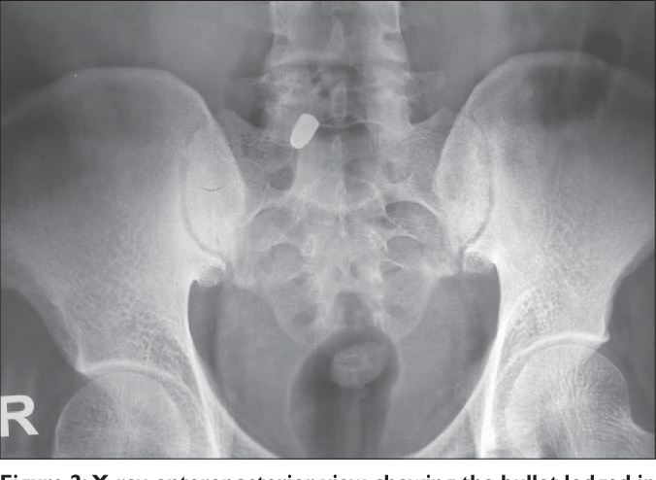

From: Wani AA, Ramzan AU, Shoib Y, Malik NK, Nizami FA, Dhar A, Alam S. Stray bullet: An accidental killer during riot control. Surg Neurol Int. 2011;2:122. doi: 10.4103/2152-7806.84769. Epub 2011 Sep 10. PMID: 22022659; PMCID: PMC3198307.

FAST – Positive Free Fluid in Abdomen, Normal Lung Sliding, No pericardial effusion

From: The POCUS Atlas

Appendix C: Facilitator Cheat Sheet & Debriefing Tips

Include key errors to watch for and common challenges with the case. List issues expected to be part of the debriefing discussion. Supplemental information regarding any relevant pathophysiology, guidelines, or management information that may be reviewed during debriefing should be provided for facilitators to have as a reference.

Massive Transfusion
- Must send G&S first
- Start with pRBC kept in department (uncross-matched blood) or pre-order blood if time available
- Activate protocol
- Alternate to maintain 1:1:1 (some centres use 1:1:2 – ie. Twice as much pRBC as FFP/plts)
- Alternate between:
  - 2 PRBC + 2 FFP + 1 adult bag platelets
  - 2 PRBC + 2 FFP

Best Indicator for Massive Transfusion
ABC Score (SBP<90, HR>120, positive FAST, pen trauma) 2 or more = likely MT
RABT Score (pen trauma, positive FAST, SI > 1, pelvic #) 2 or more = likely MT

TXA Dosing in Trauma
- 1g iv over 10 minutes, then 1 g iv over 8 hours as infusion (some protocols call for 2g up front)

Management of Penetrating Trauma
- Not all patients need to go to OR
- Shotgun wounds at close range are highest risk for multiple injuries and high mortality

- This patient had peritoneal signs
- This patient had evidence of hemodynamic instability
- High risk wound contamination, bowel injury, open fracture: therefore must also give Abx

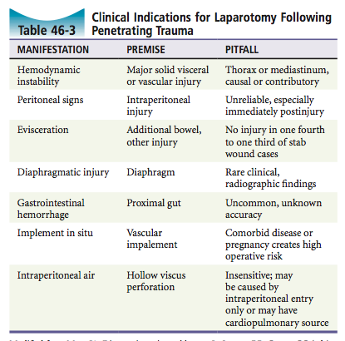

Some Sample Questions for Debriefing:
- What made you decide that the patient needed transfusion?
- How are gunshot wounds primarily managed?
- How do you give a massive transfusion?
- What are some adjuncts to consider giving during a massive transfusion?
- What is the dosing of TXA in trauma?
- How do you prepare a resus room for a major trauma?
- How do you prepare a team for a major trauma?

References

1.
2.
3.

